QCDE RCON guide

Accessing the console of your Doom2, Zandronum, or Gzdoom server is important for maintaince, troubleshooting, and administration. Having access to the the physical machine is not a possible or practical if the server is running on a dedicated server or you are in the game. Remote console (RCON) is the way to access the console of the server without being at the device physically.  
  
You will need 3 thing to access the remote client: the ip address of the server, the RCON password set on the server, and the client software.   
  
First the ip address is the easiest to get since it’s the same as the address you connect to.

To set the RCON you must set the variable for sv_rconpassword either on the command line or server config. If you just have a simple server with no files exposed to the public you can just add the variable to the config file.  
  
sv_rconpassword "changeme" //remote console password for administration

If you are using a dockerized server you may not be able to edit the config files easily. Typically, dockerized servers have config files listed on github which means everything is exposed, so you may not want to have the variable listed on configs. However, you can put the variable in the launch string.   
  
q-zandronum-server -iwad freedoom2.wad -file QCDEv3.0.pk3 QCDEmaps3.0.pk3 -optfile QCDEmus3.0.pk3 +exec qcde-dm.cfg +exec LAN.cfg +sv_rconpassword "testpass"   
  
Either method will set the config   
  
Last you will need the client software. If you have QCDE isntalled then you have what you need. All you must do is open the QCDE/Doomseeker and find the server.

Right click on the server and click on remote console.

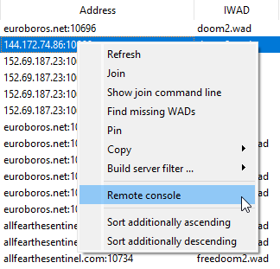

put in the password, and you have full access.

